HK INSTITUTE OF VOCATIONAL EDUCATION
DEPARTMENT OF INFORMATION AND COMMUNICATIONS TECHNOLOGY

ITP4910 Software Development Project

LAB 05 – Database Management Using Datasets

Objectives:
- To generate a DataSet to connect a Access Database
- To populate a DataSet object with data from the database by the Fill and GetData methods of a TableAdapter
- To bind some basic controls on a form by a BindingSource component.
- To navigate data with the BindingNavigator Control
- To change the contents of a database

Part A Adding a connection to a database and generating the Dataset
Part B: Navigating Data with the BindingNavigator Control
Part C: Saving Data to a Database using the BindingNavigator Control

Part A Adding a connection to a database and generating the Dataset

Visual Studio 2010 has strong supports for working with databases. One of them is a strongly typed DataSet for building applications that work with data from a database. DataSets are objects that contain data tables where you can temporarily store the data for use in your local memory. The structure of a DataSet is similar to that of a relational database and it exposes a hierarchical object model of tables, rows, columns, constraints and relationships. You can work with the data in a DataSet even if your application becomes disconnected from the database. The DataSet maintains information about changes to its data so updates can be tracked and sent back to the database when your application becomes reconnected.

DataSets can be typed or untyped. A strongly typed DataSet can be created by creating an XSD (XML Schema Definition) using the XML schema editor and is easier to program against. In most cases, the source of the data will be a database, in which case Visual Studio 2010 provides a wizard that you can use to generate the necessary schema based on the structure of the database and generate the typed DataSet.

- Download a database ITP4910-Lab05-DB.zip.

- Create a new project of type Windows Applications. Enter Lab05 as its name.

- Create a new form Form1 with text “DataSets”. Unzip the lib.accdb database files and place them inside the Debug directory of your application. Close the visual studio and restart it again
- Open the Data menu and then Add New Data Source.
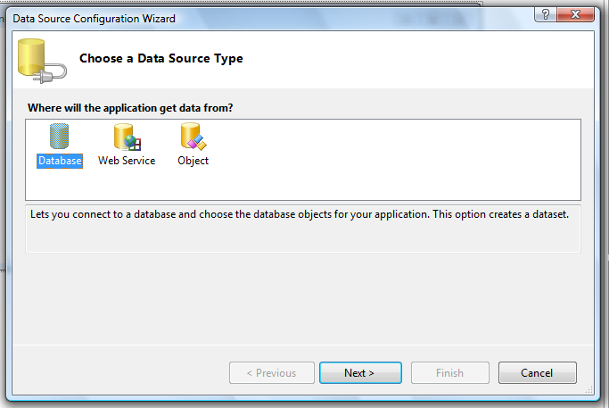

- Choose Database and then click on the Next button.

- Click on New Connection and select Add connection in the Choose Your Data Connection dialog box that appears.

- In the Add Connection dialog box that appears, the Data Source should be “Microsoft Access Database File (OLEDB).” Click on the “Browse … ” button to the right of the “Database file name” text box. Select the file lib.accdb from the Debug folder of your application and press Open.

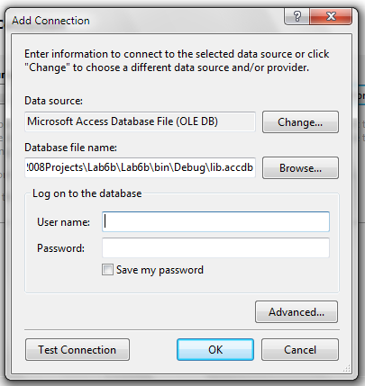

- Press the Test Connection button. The message “Test Connection Succeeded” will appear. Press the OK button on the message box and then press the OK button on the Add Connection box.

- Then click on the Next button on the Data Source Configuration Wizard window.
- Click No in the dialog box that appears.

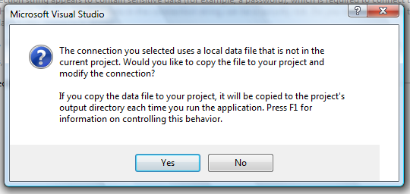

- Accept the default name of the connection string as “libConnectionString” and click on the Next button to save your connection string in the Application Configuration file.
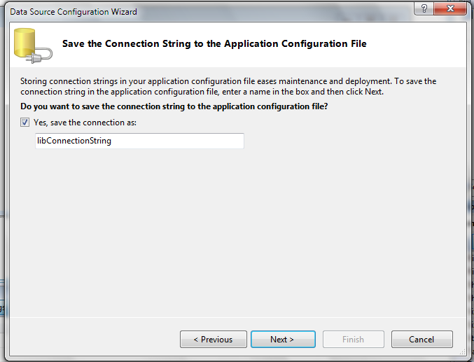

- After specifying the connection, the next stage is to specify the data to be extracted. Click all the tables so that they can be all included in the DataSet generated. Rename the DataSet as “libDataSet”

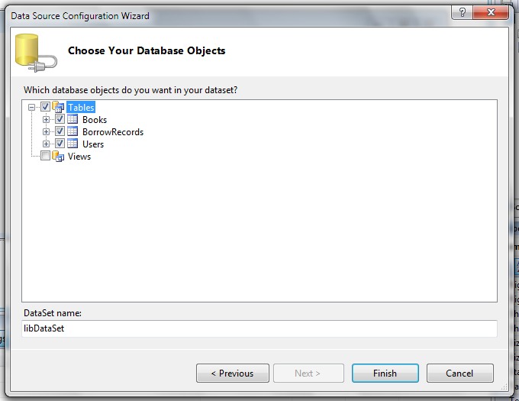
Hint: For the time being, simply select all tables and all fields and you can delete any information not useful in the DataSet Designer afterwards.

- Click on the Finish button to add the new DataSet to the Data Sources Window where you can view all the information to be retrieved for the DataSet.

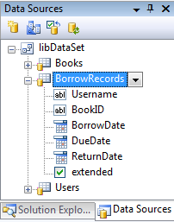

- Select Edit DataSet with Designer from libDataSet’s menu bar in the Data Sources window to view the XSD file of the libDataSet.

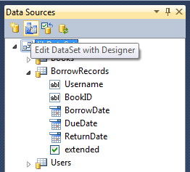

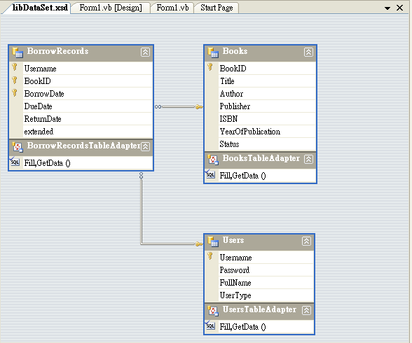

Hint :
- Alternatively the XSD file can be viewed by double-clicking on the libDataSet.xsd file in the Solution Explorer window.
- TableAdapters are used for selecting and updating the databases for the DataTable to which it is attached. If multiple tables are included in the DataSet, you will have a TableAdpater for each. Although a single TableAdapter can easily handle returning information from multiple tables in the database, it becomes difficult to update, insert and delete records.
- As it can be seen in the XSD file, the strongly typed TableAdapter has Fill and GetData methods which are called for extract data from the database.
- The Fill method can be used to populate an existing strongly typed DataTable.
- The GetData method creates a new instance of a strongly typed DataTable.

- Add a DataSet to the form and accept the default name as Lab05.libDataSet.
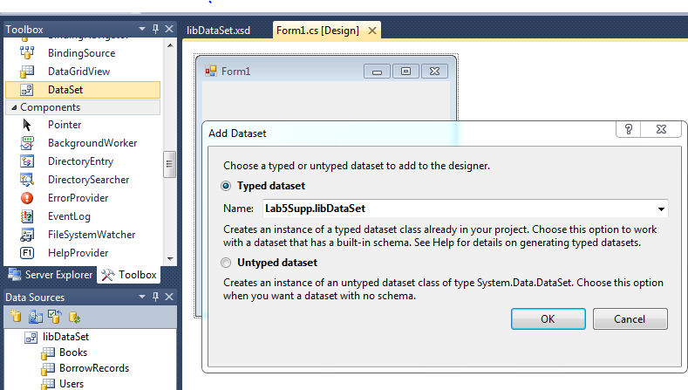
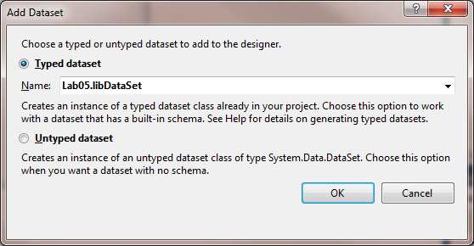

Hint :
- The LibDataSet1 that is added to this form is actually an instance of the libDataSet class that was created by the Data Source Configuration Wizard. This instance will be used to store information for all the tables on the form.
- If you can find libDataSet in the Toolbox, you can just add a libDataSet to Form1.

- Add a DataGridView named dgvBooks to Form1.
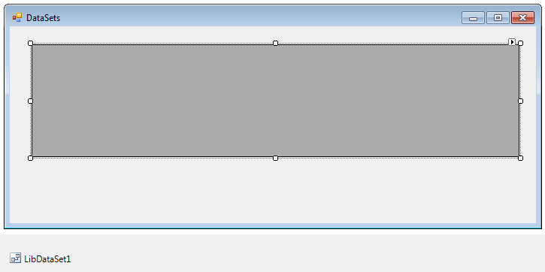

- Add code in the Form Load event to fill a DataTable object with data from the database through a DataAdapter object.

private void Form1_Load(object sender, EventArgs e) {
libDataSetTableAdapters.BooksTableAdapter ta =
new libDataSetTableAdapters.BooksTableAdapter();
libDataSet.BooksDataTable booksTable =
new libDataSet.BooksDataTable();

ta.Fill(booksTable);
dgvBooks.DataSource = booksTable;
}

Hint :
- A DataSet contains no actual data by default. Filling a DataSet with data actually refers to loading data into the individual DataTable object that makes up the Dataset.
- The statement
ta.Fill(BooksTable)
call the Fill method of the BooksTableAdapter ta to load data to the BookTable.

- Run the program to see if the DataGridView dgvBooks displays the data of Books table correctly.
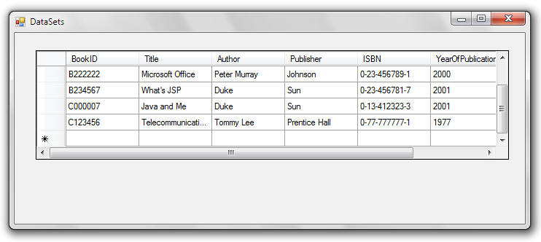

- Add another DataGridView named dgvUsers.
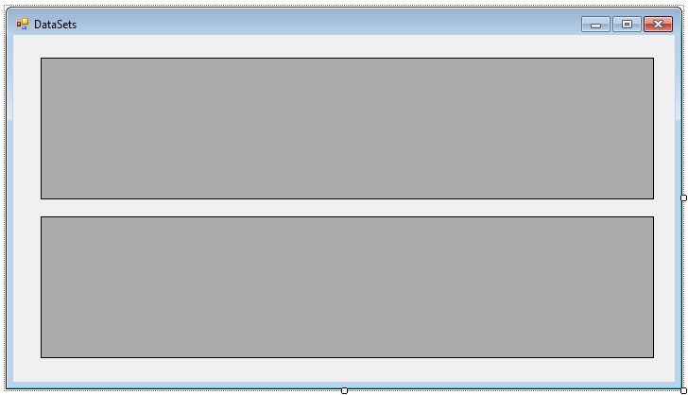

- Add the following code in the Form Load event.

libDataSetTableAdapters.UsersTableAdapter taUsers =
new libDataSetTableAdapters.UsersTableAdapter();
libDataSet.UsersDataTable usersTable =
new libDataSet.UsersDataTable();

taUsers.Fill(usersTable);
dgvUsers.DataSource = usersTable;

Hint : The taUsers.GetData statement will create a new instance of a UserTable and the word new is not necessary here.

- Run the program to see if the DataGridView dgvUsers displays the data of Users table correctly.

Part B: Navigating Data with the BindingNavigator Control

Visual Studio 2010 dramatically reduces the pain of getting two-way data binding to work for the developers. We are going to examine the data-binding controls in more details and how to use the BindingNavigator control to navigate and manipulate data.

- Create a new form named Form2 with text “Data Binding”. When running your Form2, remember to change the start-up form of your project to Form2.

- In the Data Sources window, drag the Users node onto the form design surface. This will add a DataGridView control of the columns of the Users table. It will also add a usersBindingSource, a usersBindingNavigator, a libDataSet and a usersTableAdapter to the form. Expand the User node in Details and drag the FullName field onto the form so that a text box with a label is created.
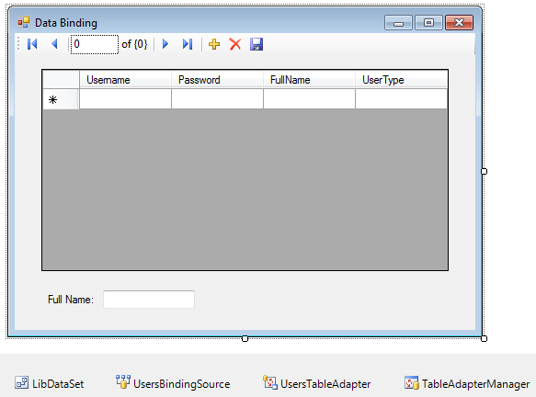

- Run the program to see if the Users table data can be viewed through the DataGridView and the text box. Try to navigate through the records using the navigation control (the usersBindNavigator)

Hint :
- The LibDataSet that is added to this form is actually an instance of the libDataSet class that was created by the Data Source Configuration Wizard. This instance will be used to store information for all the tables on the form.
- To populate the DataSet, the Fill method is needed. If you open the code file for the form, you will find that the Fill command has been added to the form’s Load event handler automatically.

private void Form2_Load(object sender, EventArgs e) {
this.usersTableAdapter.Fill(this.libDataSet.Users);
}

You can add other TableAdapters to work with different tables within the LibDataSet.
- The usersBindingSource automatically added to the nonvisual part of the form designer will help to reduce the number of event handlers and custom code that you have to write.
- The BindingSource component simplifies the binding controls on a form to data by attaching the BindingSource component to the data source and then binding the controls on the form to the BindingSource component.
- Take a look at the properties of the usersBindingSource. For the DataSource property, the instance of LibDataSet should be listed under Form2 List Instances. In the DataMember field, the Users table should appear.
- The usersBindingNavigator component is an instance of the BindingNavigator class. Although this control appears in the nonvisual area of the design surface, it has a visual representation in the form of the navigation toolstrip that is initially locked to the top of the form.
- The BindingNavigator component in Windows Forms enables developer to provide end users with a simple data navigation and manipulation user interface on the forms.
- When the usersBindingNavigator is initially added to the form, a series of buttons are added for standard data functionality, such as moving to the first or last item, moving to the next or previous item, and adding, removing and saving items.
- Check the BindingSource property of the usersBindingNavigator and it should be the usersBindingSource

- Create a new form named Form3 with text “Data Binding”.

- In the Data Sources window, set the mode of the Users node to Details using the drop-down list. Drag the Users node onto the form design surface. This will add four text boxes with labels onto the form and will also add a usersBindingSource, a usersBindingNavigator, a libDataSet and a usersTableAdapter to the form.
- Add a button with name and text as “btnClose” and “Close” respectively.
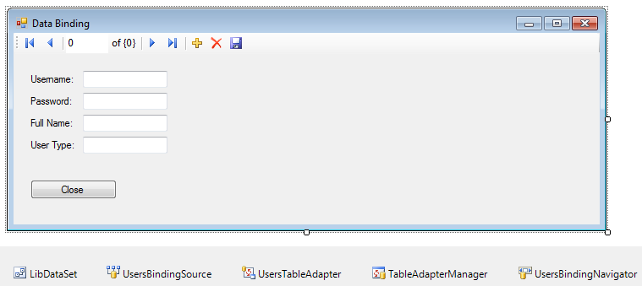

- Add code for the event btnClose_Click.

private void btnClose_Click(object sender, EventArgs e) {
this.Close();
}

- Add a button in Form2 with name and text as “btnDetails” and “Show Details View” respectively. Add code for the event btnDetails_Click

private void btnDetails_Click(object sender, EventArgs e) {
Form3 frm = new Form3();
frm.ShowDialog();
}

- Run the program and click the Show Details View button to see the data binding in Form3. Click on the Close button to return to Form2.

- Remove the first three text boxes and the labels for Password and Full Name. Add a ComboBox control from the toolbar. With the new ComboBox selected, expand the smart tag attached to it and check the “User data bound items” checkbox.
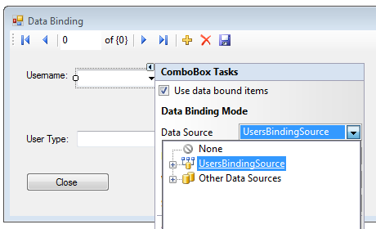

Hint : The Username is in fact a foreign key to the BorrowRecords table. It would make sense to present a drop-down list that enables users to select the names rather than specifying any name.

- Four things are needed to be defined in the Data Binding Mode. The first is the Data Source. In this case, select the existing UsersBindingSource that was previously added to Form3.

- The Display Member field is that field that is to be displayed. In this case, set it to the FullName column of the Users table.

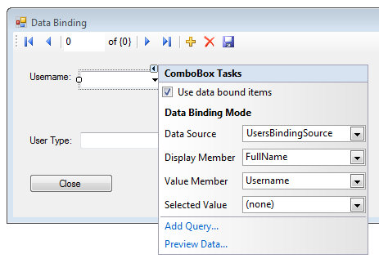

- The Value Member is the field used to select with item to display. Set it to the Username column of the Users table.

- The Selected Value property determines which item will be selected and what property to update when the selected item changes in the drop-down list. Set it to none in this case.

- Run the program to see if the Full Names of the Users can be displayed in the combo box correctly.

Hint : If you find that the value in the User Type textbox does not change accordingly when you navigate your records, delete it and drag another UserType textbox from the Data Sources window.

- In the Data Sources window, drag the BorrowRecords node under the Users node to Form3.
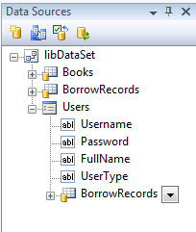

A borrowRecordsTableAdapter, a borrowRecordsBindingSource and a DataGridView will be added to the form.

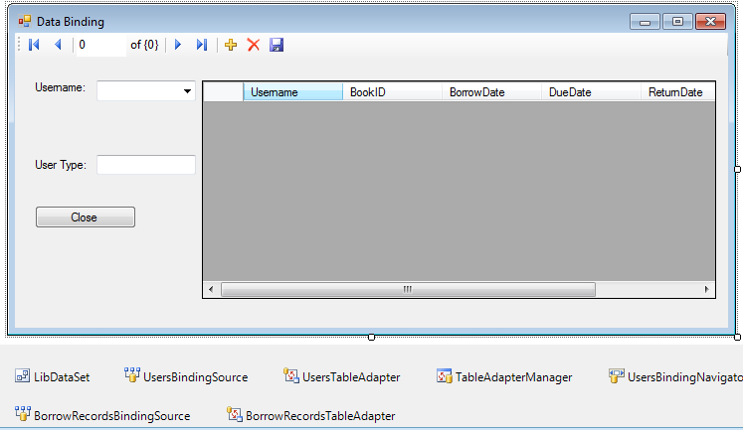

- Run the program and try to select different users in the combo box. The borrow records of the user selected should be displayed in the data grid view beside.

Part C: Saving Data to a Database using the BindingNavigator Control

By default, the BindingNavigator control’s user interface is composed of a series of ToolStrip buttons, text boxes and static text elements for most common data-related actions, such as adding data, deleting data and navigating through data. A Save button with a default event handler is also provided to send updates to the database.

Change the database using a DataGridView

- Run the program and find the record for test3. Change the UserType value to “A”. Click on the Save button.
- Add a new record with the following entries and click on the Save button.

Username : test5
Password : test5
Full Name: David Wong
User Type : N

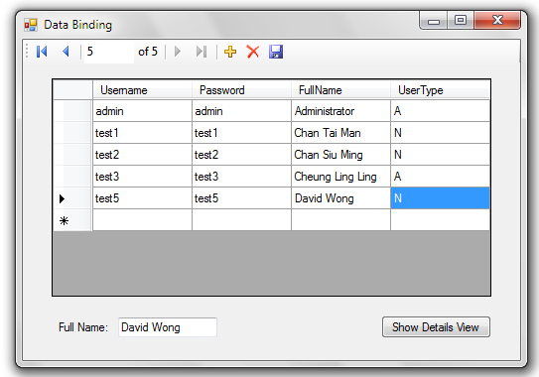

Hint :
- To update a record, highlight the field in the data grid and make the modification.
- To insert a new record, click on the bottom row that begins with an asterisk and has blank fields.
- To delete a row, click on the box to the left of a row so that the entire row is highlighted, then press the Delete key or the Delete button on the navigator control.

- Close Form2 and run the program again. Can you find your modifications to the test3 record and can you find the new record?

- Run the program again and delete the newly added record for test5. Click on the Save button.

- Close Form2 and run the program again. Can you find the deleted record? Stop the program.
Formatting the DataGridView

- Click the arrow icon on the DataGridView control on Form2 to show its design.

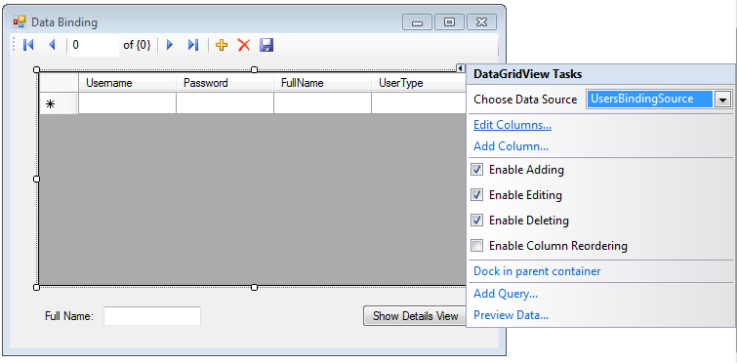

- Click Edit Columns to pop up the Edit Columns Window.

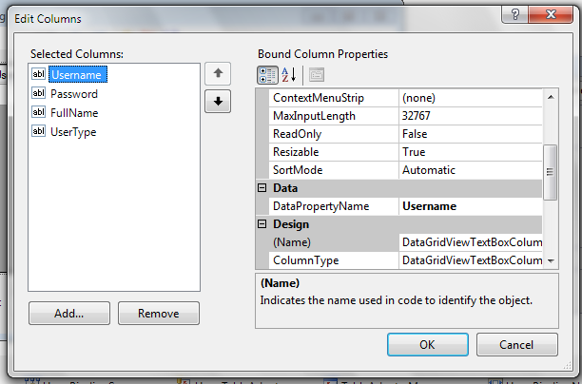

- Set the Username and Password fields to read-only so that these two fields cannot be modified and click on the OK button.

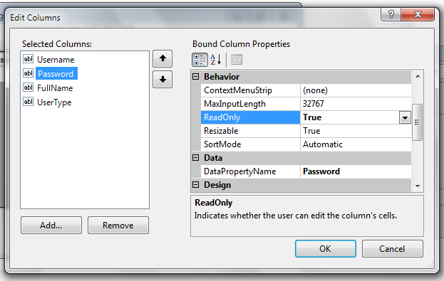
- Run the program again and try to modify the Username and Password of any record to see what happens. Close Form2.

Hint : In some cases, you may need to change the default settings of the DataGridView (e.g. set certain columns to read-only, hide some columns, set different column-width or change the header text of a column, etc.), you can use the above method to do so.

Change the database using a Details View

- Create a new form named Form4 with text “Updating the database” and choose it as the start-up form of the project.

- In the Data Sources window, set the mode of the Users node to Details using the drop-down list. Drag the Users node onto the form design surface.

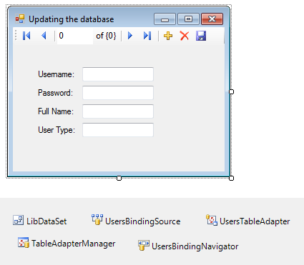

- Run the program and navigate to the fourth record.

- Change the Password value to “test4” and change the UserType value back to ”N”. Click on the Save button.

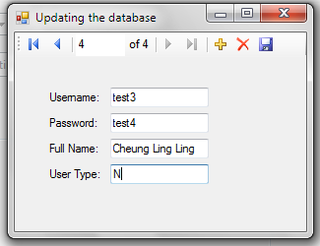

- Move to the first record and then navigate back to the fourth record. You should find that the changes are maintained.

- Click on the Add New button and add a new record with the following entries:

Username : User5
Password : User5
Full Name: David Wong
User Type : N

Click on the Save button.

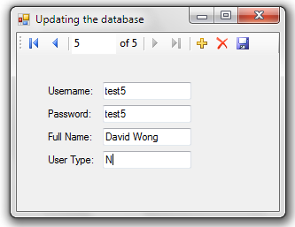

- In the Code window of Form4, study the code used to update the database

private void usersBindingNavigatorSaveItem_Click(...) {
this.Validate();
this.usersBindingSource.EndEdit();
this.tableAdapterManager.UpdateAll(this.libDataSet);
}

Hint :
- The code were generated automatically by Visual Studio.
- If you need to update more than one table by the same button, you need to modify the method. For example, if you need to save changes made to both the Users Table and the Books Table, the method should be modified as

private void usersBindingNavigatorSaveItem_Click(...) {
this.Validate();
this.usersBindingSource.EndEdit();
this.booksBindingSource.EndEdit();
this.tableAdapterManager.UpdateAll(this.libDataSet);
}

- Please be careful that in some cases, the changes of some tables must be saved before those of the other tables. Why?

